A Practical record on

EXPLORATORY DATA ANALYSIS USING EXCEL (BCADA1P2)
Submitted in partial fulfillment of the requirement for
Bachelor of Computer Applications in Data Analytics

Submitted by
DENNIS MICHAEL T
REG NO: 231BCADA13



ST. JOSEPH’S UNIVERSITY, BENGALURU -27

DEPARTMENT OF ADVANCED COMPUTING

2023-2024

CERTIFICATE

This is to certify Mr./Mrs.
“……………………………………………………………… …………………………………………………………………
…” has successfully completed in 1st semester Data analytics lab using Excel prescribed by ST. JOSEPH’S UNIVERSITY, under Department of Advanced Computing - BCA Data
Analytics course in the year 2023 - 2024.

Signature of the Teacher in-charge of the Batch

Head of the Department

INDEX
1. ASSIGNMENT – 1 4-13 DATA : TRUCK MODEL SOLD
• FINDING FREQUENCY, RF, PLOTTING BAR GRAPH, PIE CHARTS AND
PIVOT TABLE AND GRAPHS

2. ASSIGNMENT – 2 14-23
DATA : CUSTOMER WAITING TIME
• BINS, FINDING FREQUENCY AND HISTOGRAM

3. ASSIGNMENT – 3 24 & 25
DATA :ADVERTISING AND SALES
• PLOTTING SCATTER GRAPHS

4. ASSIGNMENT – 4 26-30
DATA : AVERAGE OF DAILY LOW AND HIGH
TEMPERATURES
FINDING MEAN, MEDIAN, MODE, VARIANCE AND
STANDARD DEVIATION

5. ASSIGNMENT – 5 31-37
DATA : SCORE AND STUDENT
FINDING VARIANCES,
STANDARD DEVIATION

6. ASSIGNMENT – 6 38-46
DATA : HEIGHT AND WEIGHT
FINDING VARIABILITY, SD, PLOTTING WHISKER GRAPHS

10. ASSIGNMENT – 7
DATA: RANDOM NUMBERS GENERATION USING EXCEL
FINDING RANDOM NUMBERS USING FUNCTIONS.
FINDING RANDOM NUMBERS FOR BINOMIAL AND NORMAL DISTRIBUTION
7. ASSIGNMENT – 8
DATA: CUSTOMER WAITING TIME

8. ASSIGNMENT – 9
DATA : DAILY DEMAND AND OCCURENCES
• FINDING PROBABILITY,
EXPECTED MEAN AND STANDARD
DEVIATION

9. ASSIGNMENT – 10
DATA : HEIGHT AND WEIGHT & HEART CV
• FINDING CORRELEATION

ASSIGNMENT – 1

GIVEN DATA
Truck Model Sold
Toyota Tacoma
Ram P/U
Chevrolet Silverado
Chevrolet Silverado
Toyota Tundra
GMC Sierra
Ram P/U
Toyota Tacoma
Ford F-Series
Ram P/U
Ford F-Series
Chevrolet Silverado
Chevrolet Silverado
Ford F-Series
Ram P/U

- Find the frequency of each category and calculate the relative frequency. Create a bar plot Category vs Count and Category vs Relative Frequency.
Truck Model Sold | Count | Relative Frequency
Ford F-Series | 71332 | 31%
Chevrolet Silverado | 54977 | 24%
Ram P/U | 45310 | 19%
GMC Sierra | 21241 | 9%
Toyota Tacoma | 16230 | 7%
Toyota Tundra | 10057 | 4%
Chevrolet Colorado | 7114 | 3%
Nissan Frontier | 3645 | 2%
GMC Canyon | 2423 | 1%
Nissan Titan | 1268 | 1%
Honda Ridgeline | 4 | 0%
Grand Total | 233601 | 100%
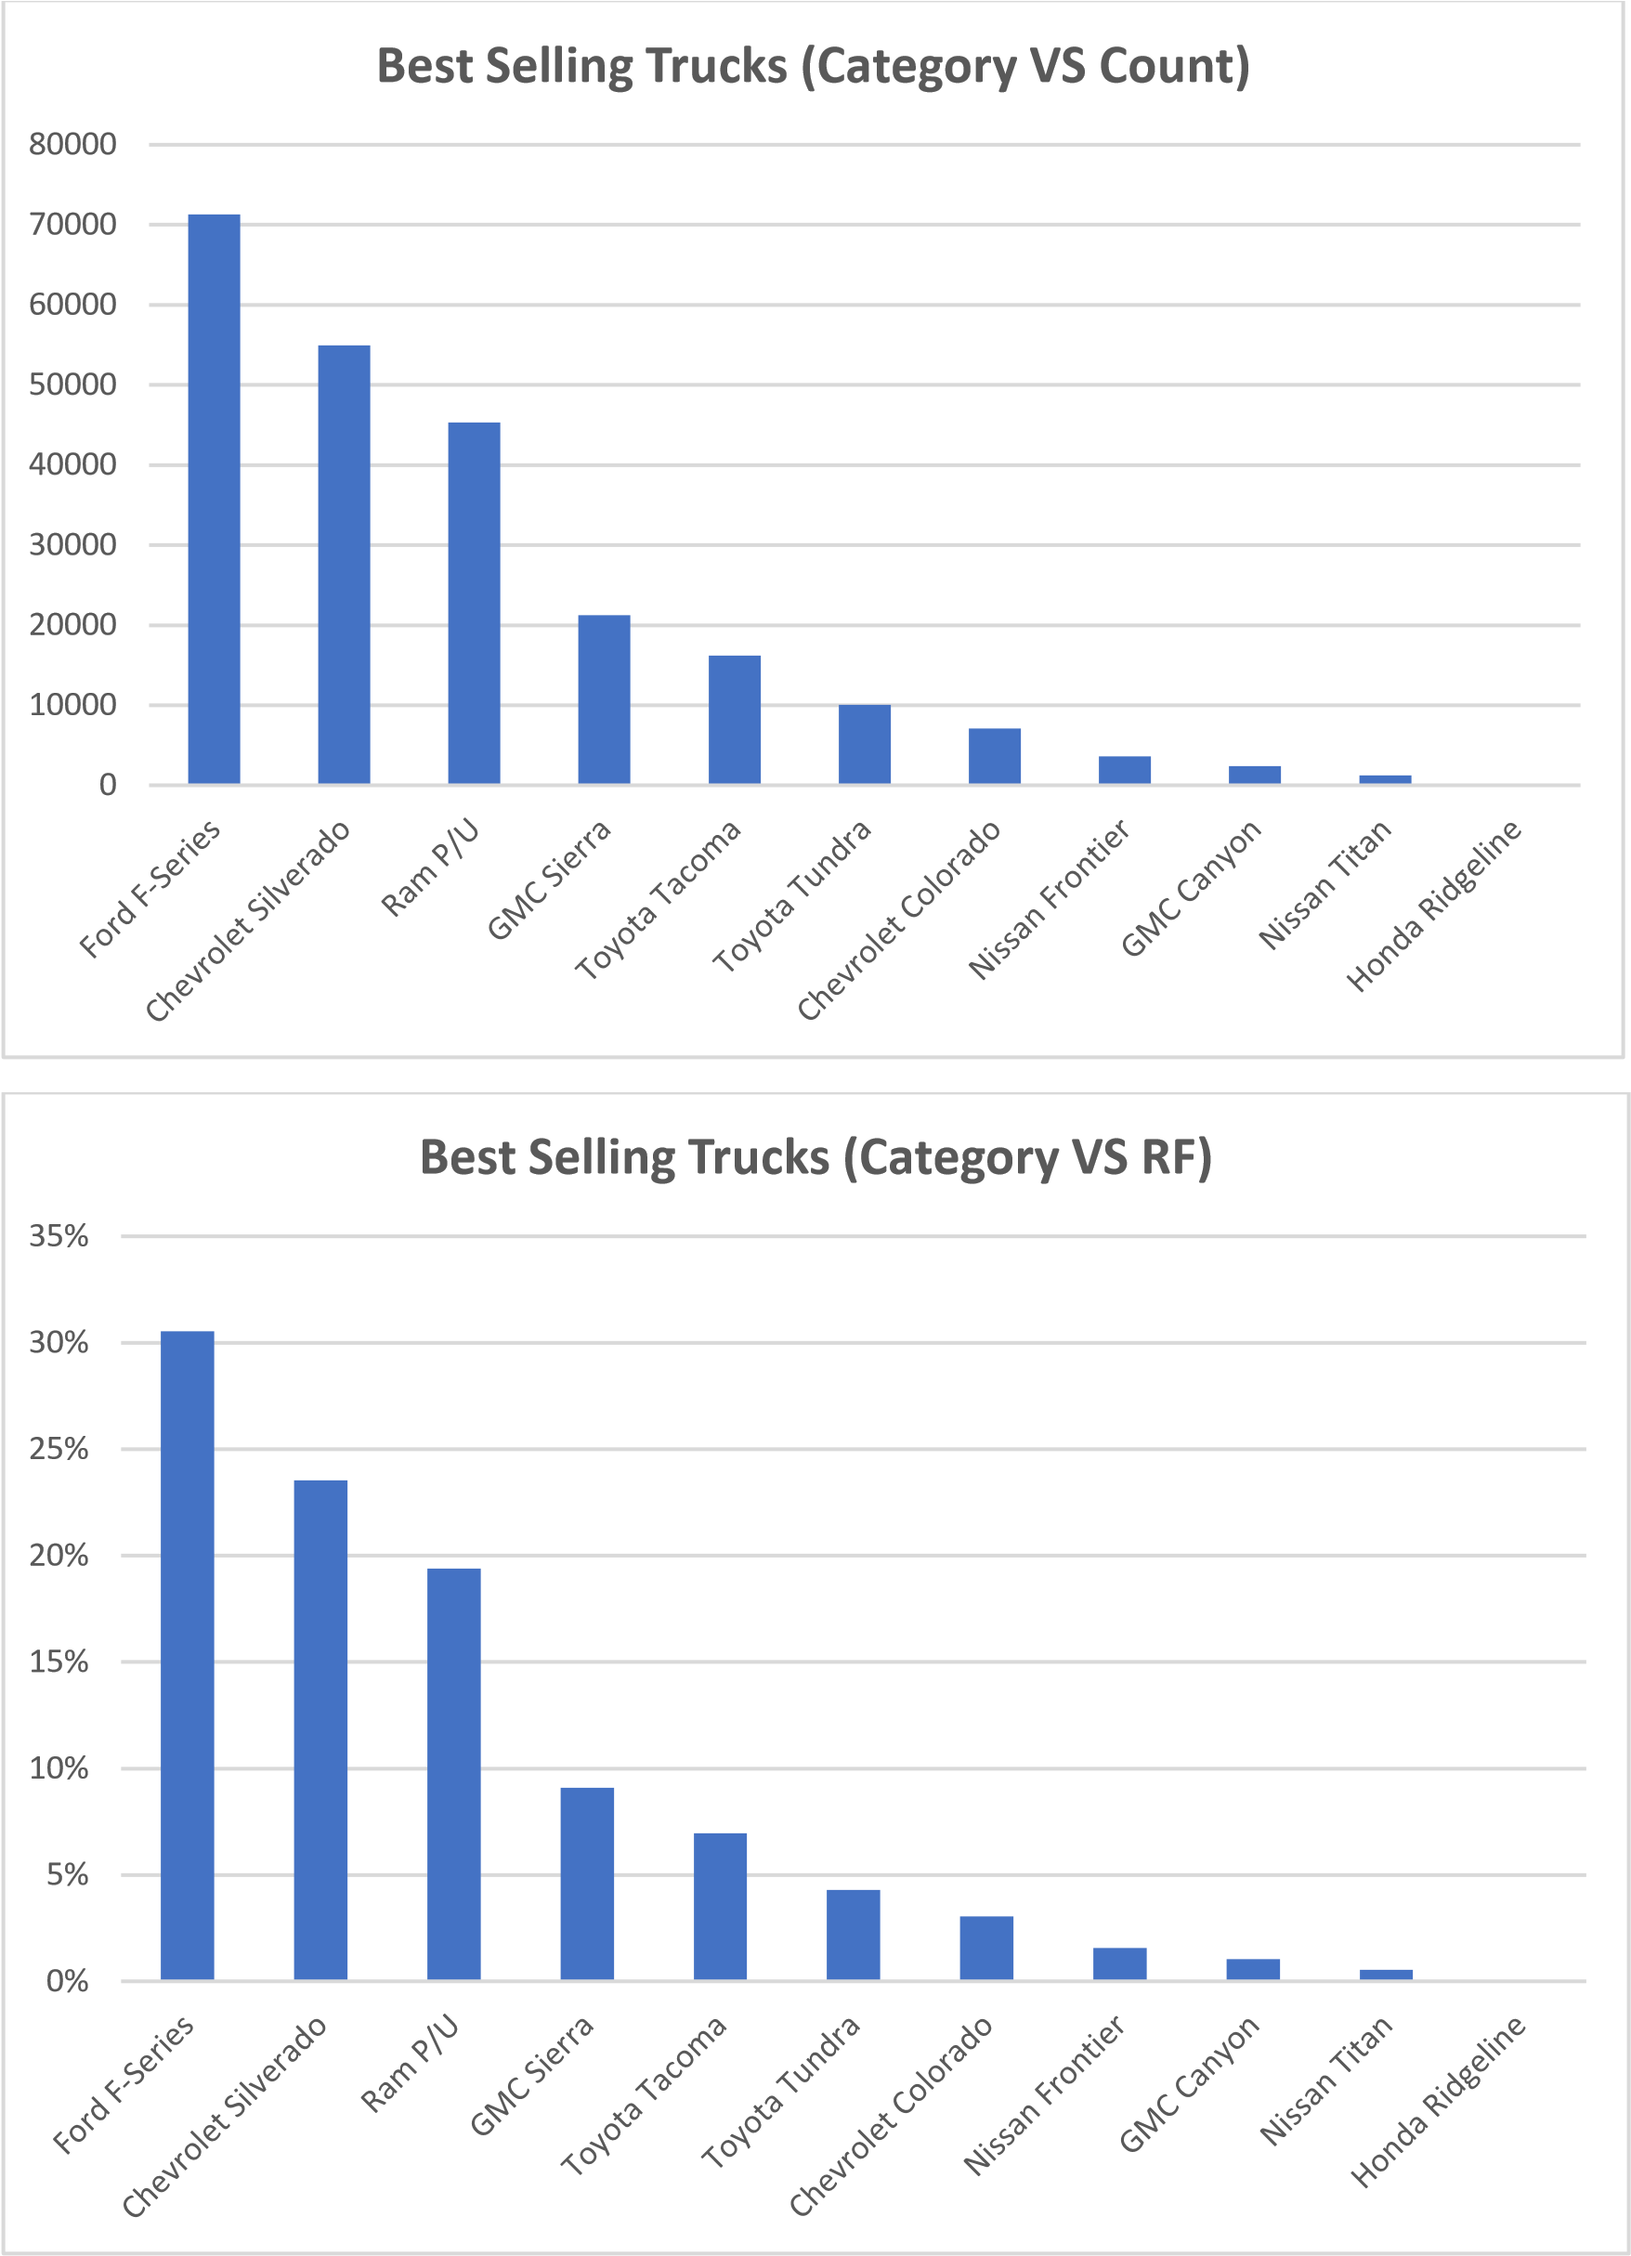

- Similarly plot a pie chart.



%
31
23
%
%
19
%
9
%
7
%
4
3
%
2
%
1
%
1
%
0
%
4
%
Best Selling Trucks
Ford F-Series
Chevrolet Silverado
Ram P/U
GMC Sierra
Toyota Tacoma
Toyota Tundra
Chevrolet Colorado
Nissan Frontier
GMC Canyon
Nissan Titan
Honda Ridgeline

- Plotting table using Pivot Table.
To plot Pivot table in Excel the user needs to follow the following steps.

Step – 1 : Select the given data.

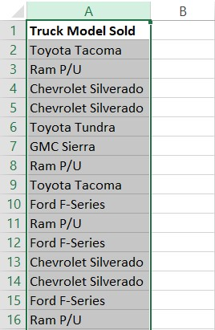

Step – 2 : After selecting the given data go to Insert Tab.



Step – 3 : Select ‘Truck Models Sold’.
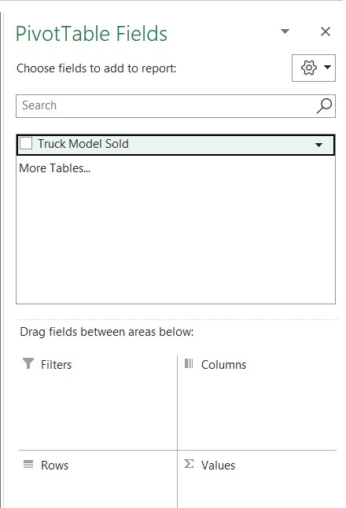

Step – 4:Drag‘Truck Models Sold’ to ‘Rows Column’.

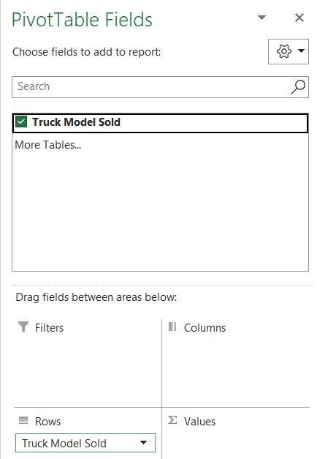

Step – 5: Drag ‘Truck Models Sold’ to ‘Values Column’.

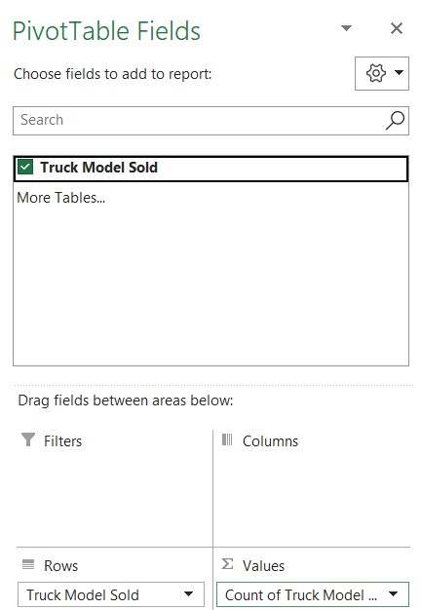

Step – 6 : Generated a pivot table.

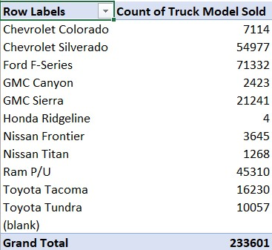

Step – 7: To get Relative Frequency of the data, select “Value Field Settings”

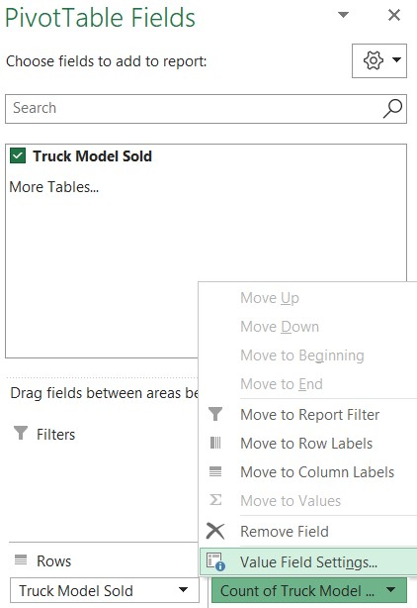

Step – 8: Select “Show Values As” .

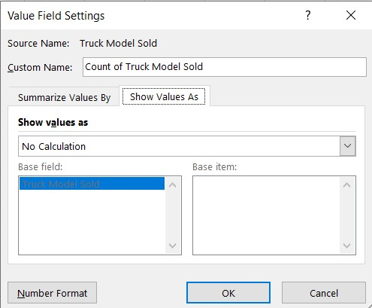

Step – 9 : Select “% of Column Total” option and select OK.

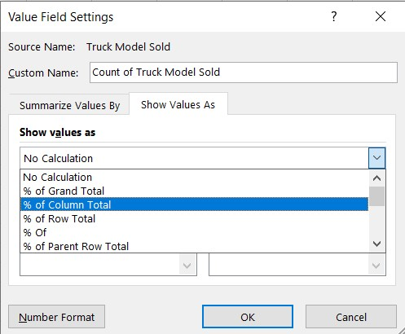

Step – 10 : Select OK.
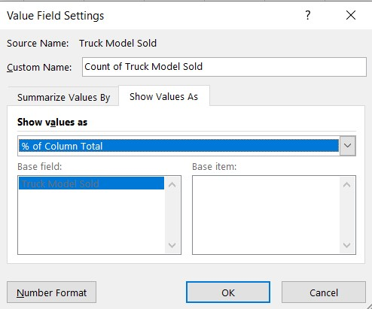

Step – 11 : FINAL OUTPUT OF PIVOT TABLE.

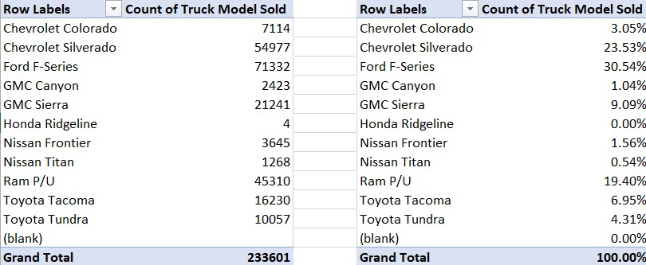

Step – 12 : Bar Graph.
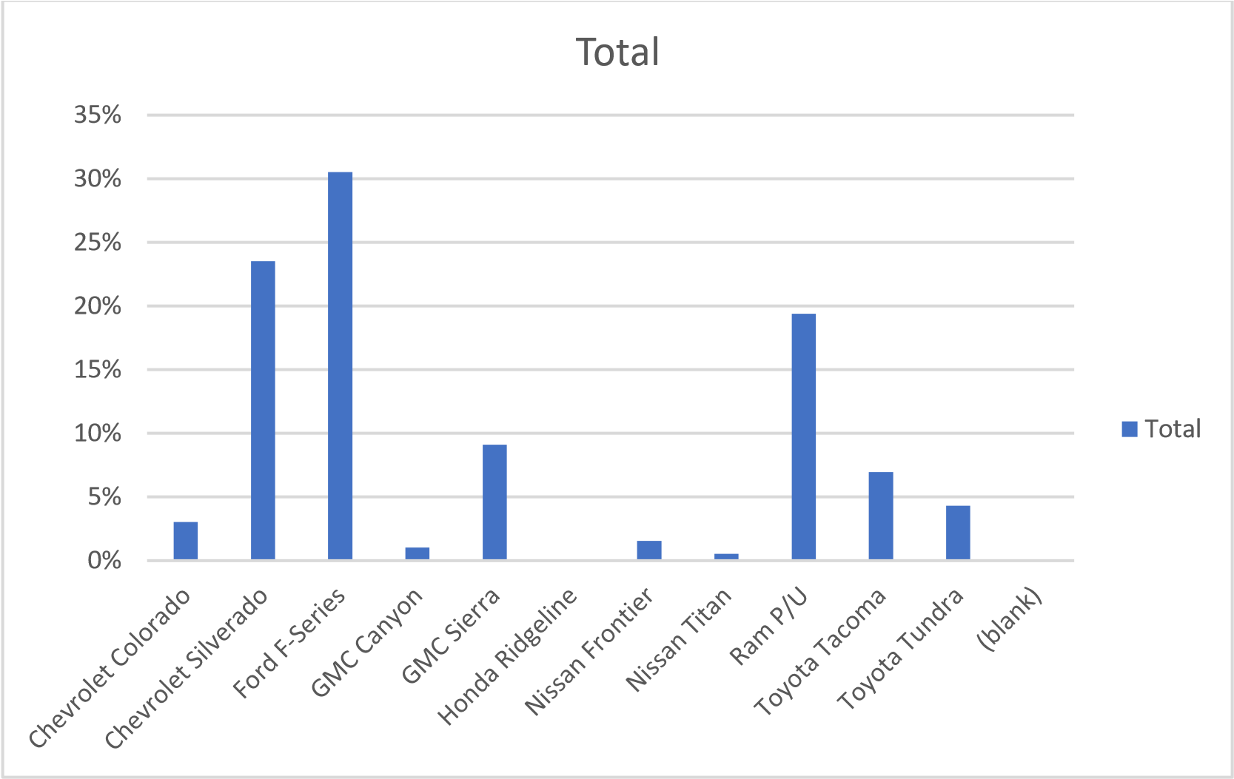

Summary.
Here we can see that There is a sale of 233601 units trucks in a year. In this year, Ford F-Series truck model is the best-selling truck of the year with the sales of 71332 units occupying 31% of the trucks market. Whereas Honda Ridgeline had did the sales of only 4 units which is the least.
Here we have used =uniqueif() to find the unique record , =countif() for finding count and =count/total for relative frequency.

ASSIGNMENT – 2

GIVEN DATA
Customer Waiting Time (seconds)
51
95
68
243
167
288
108
83
48
251
189
128
60
290
259

1.Create a range of bins and find the frequency and relative frequency.
Bin Range | Frequency | Relative Frequency
30 | 30 | 6%
60 | 49 | 10%
90 | 40 | 8%
120 | 40 | 8%
150 | 37 | 7%
180 | 45 | 9%
210 | 66 | 13%
240 | 62 | 12%
270 | 71 | 14%
300 | 60 | 12%
Total Frequency | 500 | 100%

- Another way use data analysis toolpak to calculate the Frequency table and plot Histogram using ‘Histogram’ Function.
To generate table using data analysis toolpak, the user needs to follow the steps. Such as:-
Step – 1 : Open ‘Data’ tab and select ‘Data Analysis’ from ‘Analysis’ section.
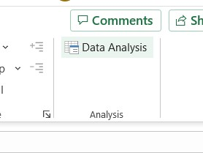
Step – 2 : Select ‘Histogram’ and click OK.
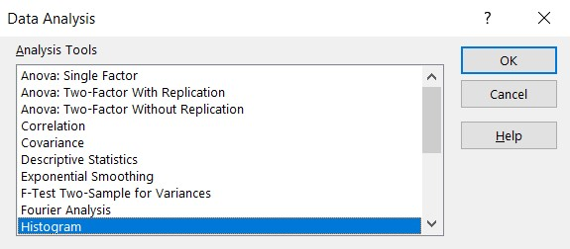

Step – 3 : Select raw data as ‘Input Range’ and select bin as ‘Bin Range’. Select labels, new worksheet and chart output and click OK.
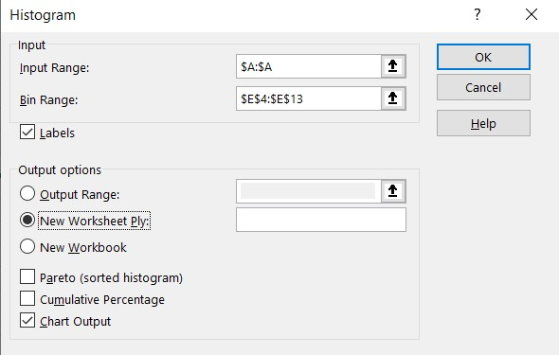

Step – 4 : Generated Result.
Bin (sec) | Frequency
30 | 30
60 | 48
90 | 40
120 | 40
150 | 37
180 | 45
210 | 66
240 | 62
270 | 71
300 | 60

- Another way we use Pivot Table to calculate the Frequency table.

Step – 1 : Click on ‘Insert’ Tab and select ‘Pivot Table’ option.



Step – 2 : Select the raw data as Table/Range, select new worksheet and click OK.
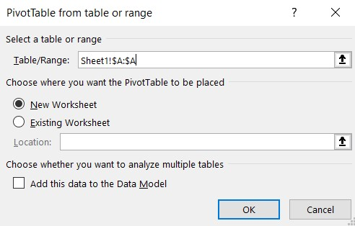

Step – 3 : Click and drag table to ‘Rows’ and ‘Values’ Section.

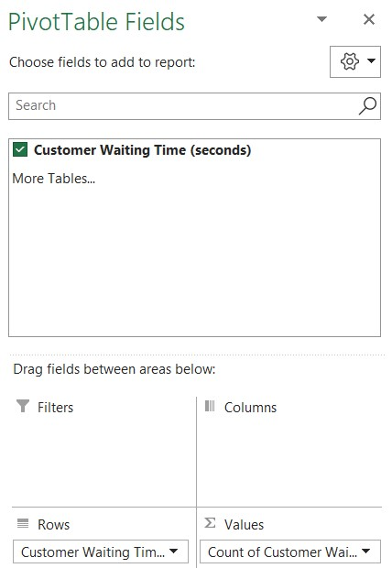

Step – 4 : To create Bin Range(class interval) we have to select the data under the column.

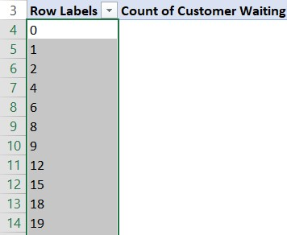

Step – 5 : Right click on the selected data and select ‘Group’ option from the menu.

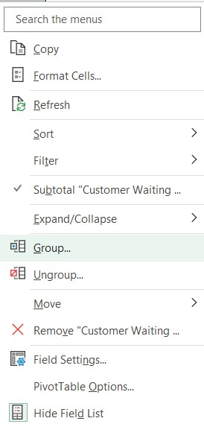

Step – 6 : Enter the following values and click OK.

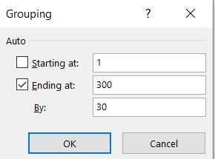

Step – 7 : Rename the ‘Frequency’ column.

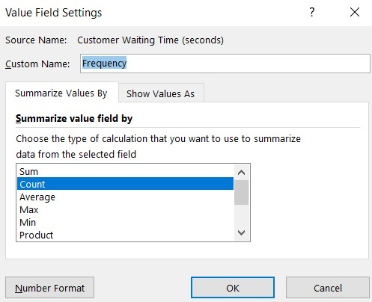

Step – 8 : Copy the table into the another location and right click on the ‘Frequency’ column and click OK.

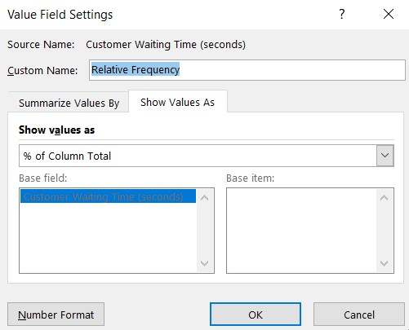

Step – 9 : Final Result.

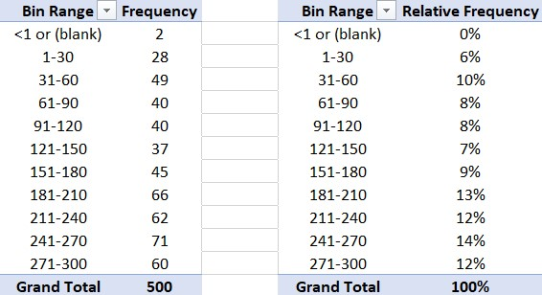

4. SUMMARY.
To find minimum we use =min() , to find maximum we have used =max() and for count=count(). To find frequency we need to use =frequency(given data, bin range) and to find total of frequencies we use =sum(frequencies). And to find relative frequency we use
=frequency/total of frequency. It can also be plotted in shortcut by using data analysis toolpack and pivot table as shown.

ASSIGNMENT - 3

GIVEN DATA
Advertising | Sales
4582.88 | 3669.88
5539.78 | 3473.95
2950.38 | 2295.10
2243.07 | 4675.56
7747.08 | 6125.96
402.44 | 2134.94
3140.62 | 5031.66
2086.16 | 3367.45
8846.25 | 6519.45
5673.11

Plot Scatter plot based on advertising and Sales.

0.00
1000.00
2000.00
3000.00
4000.00
5000.00
6000.00
7000.00
0.00
2000.00
4000.00
6000.00
8000.00
10000.00
12000.00
Advertising
Sales
Company Expenditure

- Summary.
By Plotting scatter plot we can see that there is an increment of sales in the company in that year through advertisement.

ASSIGNMENT – 4

GIVEN DATA
Day | Date | New York
1 | 9-15-2015 | 74.5
2 | 9-14-2015 | 67.0
3 | 9-13-2015 | 70.5
4 | 9-12-2015 | 74.5
5 | 9-11-2015 | 73.5
6 | 9-10-2015 | 74.5
7 | 9-9-2015 | 82.5
8 | 9-8-2015 | 85.5
9 | 9-7-2015 | 80.5
10 | 9-6-2015 | 75.5
11 | 9-5-2015 | 73.5
12 | 9-4-2015 | 77.0
13 | 9-3-2015 | 84.5
14 | 9-2-2015 | 81.5
15 | 9-1-2015 | 82.0

1. Finding central tendencies after using functions.
We’ve to find the mean, median, mode and standard deviation of the given data. And to get these central tendencies we’ve to follow the steps as follows.
To find mean, we should use =average()
To find median, we should use =median()
To find mode, we should use =mode()
To find variance, the user should use =var.s()
To find standard deviation, the user should use =stdev.s()

- Finding central tendencies using data analysis toolpak.

Step – 1 : Select ‘Data Analysis’ from ‘Analysis’ section of ‘Data’ tab.
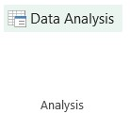

Step – 2 : Select ‘Descriptive Statistics’ and click OK.

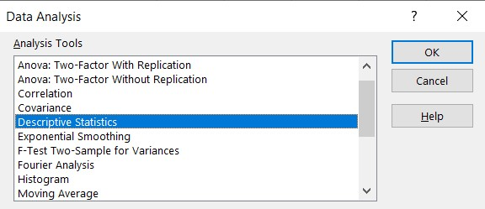
Step – 3 : Select raw data as ‘Input Range’, select the radio button of the ‘Output Range’, select ‘Summary statistics’ and click OK.
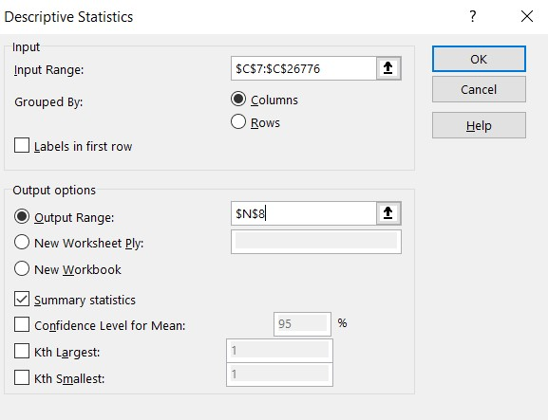

Step – 4 : Generated Result.
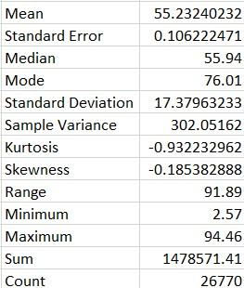

Summary.
The data given to us is the data of the temperature (in Fahrenheit) of New York City from 1st June 1942 to 15th September 2015 where we can see that the average temperature of the city has been rising from decades to decades.
The analysers can use the certain methods as mentioned before to get the descriptive central tendencies for their raw data by applying functions and in shortcut of using the data analysis toolpak by which we found the mean is 55.2, median is 55.9, mode is 76.01, variance is 302.0516, standard deviation is 17.37963.

ASSIGNMENT - 5

1. A) Find the variance and SD for the given data.

 | Student | Score | Difference | Difference^2 | Variance | Standard Deviation
 | Daniela | 85 | 0.7 | 0.49 | 40.45555556 | 6.360468187
 | Tommy | 79 | -5.3 | 28.09
 | Edward | 90 | 5.7 | 32.49
 | Julia | 88 | 3.7 | 13.69
 | Timothy | 88 | 3.7 | 13.69
 | Peter | 75 | -9.3 | 86.49
 | Neal | 92 | 7.7 | 59.29
 | Sally | 74 | -10.3 | 106.09
 | Mike | 83 | -1.3 | 1.69
 | Adam | 89 | 4.7 | 22.09
 | Total | 843 |  | 364.1
 | Count | 10
 | N-1 | 9
 | Average | 84.3
 | B) Summary statistics using data analysis toolpack.  Step – 1 : Select “Data Analysis” from Data tab. |  |  |  |  | 32

Step 2: Select “Desccriptive Statistics From Data Analysis Tool Pack

Step – 3 : Select ‘Score’ as ‘Input Range’, select the radio button of the ‘New Worksheet’, select ‘Summary statistics’ and click OK.

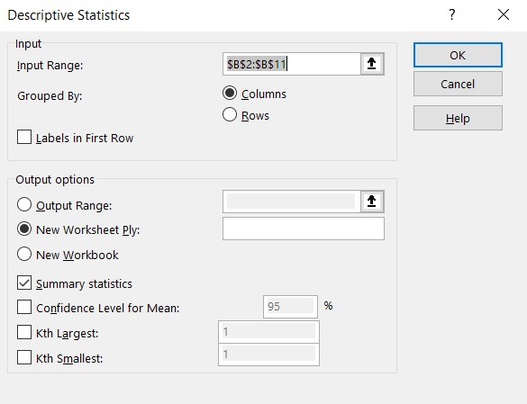

Student | Score | Difference | Difference^2 | Variance | Standard Deviation
Daniela | 85 | 1 | 1 | 57.80952381 | 7.603257447
Tommy | 79 | -5 | 25
Edward | 90 | 6 | 36
Julia | 88 | 4 | 16
Timothy
Peter | 75 | -9 | 81
Neal | 92 | 8 | 64
Sally | 74 | -10 | 100
Mike
Adam | 89 | 5 | 25
Total | 672 |  | 348
Count | 8
N-1 | 7
Average | 84
Step 4: Final Result.
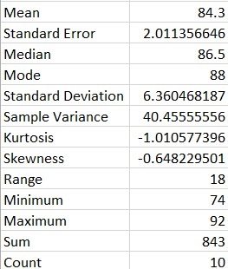

- A) Find the variance and SD for the given data with missing values.
B) Summary statistics using data analysis toolpak.
B) Summary statistics using data analysis toolpack
Step – 1 : Select ‘Data Analysis’ from ‘Analysis’ section of ‘Data’ tab.

Step – 2 : Select ‘Descriptive Statistics’ and click OK.

Step 3: Select raw data as ‘Input Range’, select the radio button of the ‘New Worksheet’ and click OK.
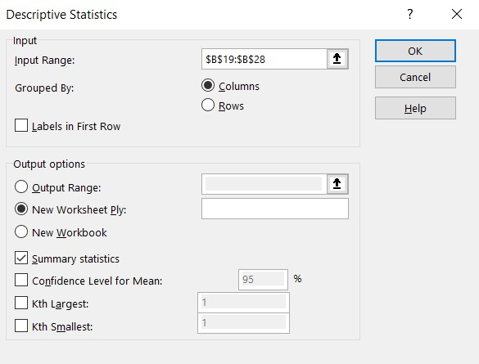
Step – 4 : Generated Result.
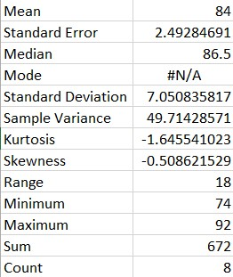
- Summary.
SUMMARY
Here for count we can use =countif() for count, n-1 ,for mean average we can use =average() =difference^2 and finding variance and standard deviation by
=sum_of_difference/N-1 and =sqrt(variance). All this can be found in shortcut way of using data analysis toolpack as mentioned steps before.
In the first complete and proper data set we can see the variance of 40.45555556 and standard deviation of 6.360468187 and so goes with the summary of data analysis toolpak. Whereas we can see in the second data set with few missing values which also makes a proper variance of 57.80952381 and standard deviation of 7.603257447 and so goes with the summary of data analysis toolpak.

ASSIGNMENT – 6

Height M | Weight kg
1.60 | 49.44
1.65 | 62.60
1.65 | 75.75
1.53 | 48.99
1.45 | 43.09
1.61 | 52.62
1.56 | 47.97
1.50 | 45.59
1.52 | 47.85
1.48 | 44.45
1.47 | 46.04
1.55 | 53.07
1.52 | 65.88
1.54 | 46.04
1.46 | 43.54
 | HEIGHT | WEIGHT
Min | 1.33 | 29.26
Max | 1.66 | 80.74
Q1 | 1.4605 | 38.72545
Q2 | 1.4986 | 44.96235
Q3 | 1.557338 | 51.19924
IQR | 0.096838 | 12.47379
LQR | 1.315244 | 20.01476
UQR | 1.702594 | 69.90993

RAW DATA (sample data)

- Find variability using QR of the given data of a class students height and weight.

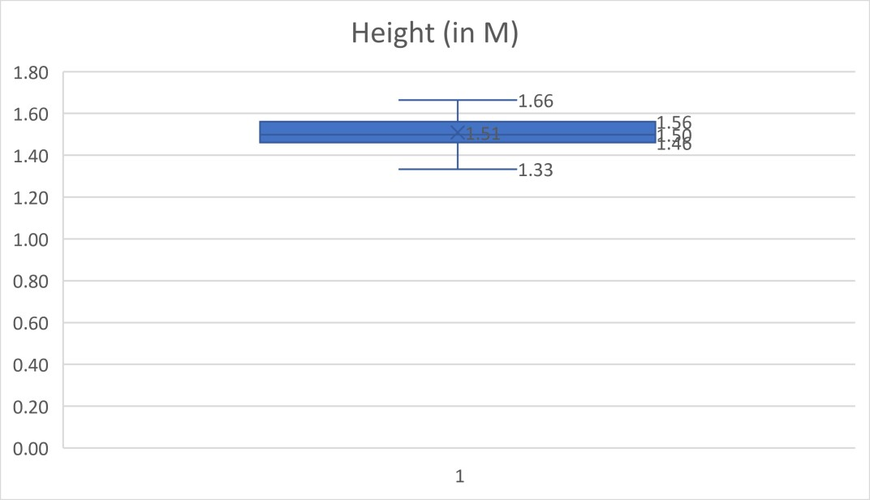
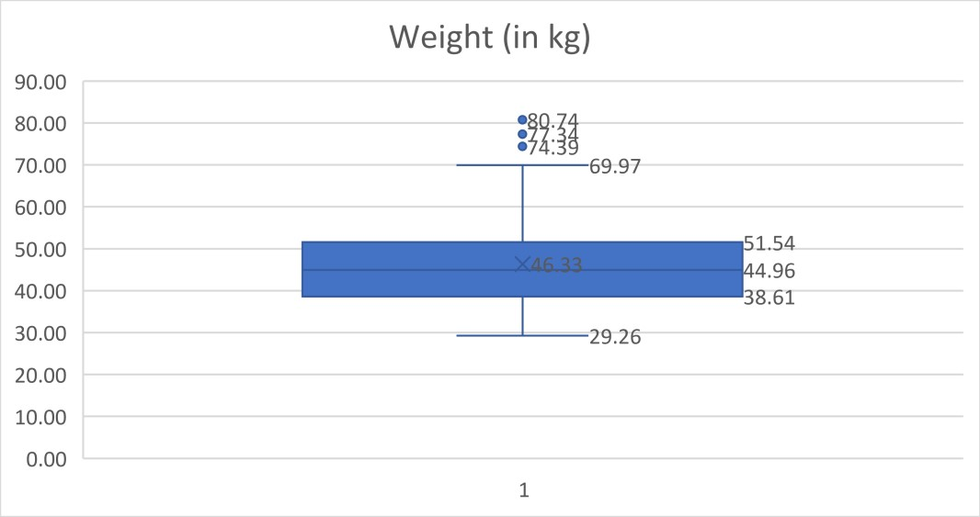
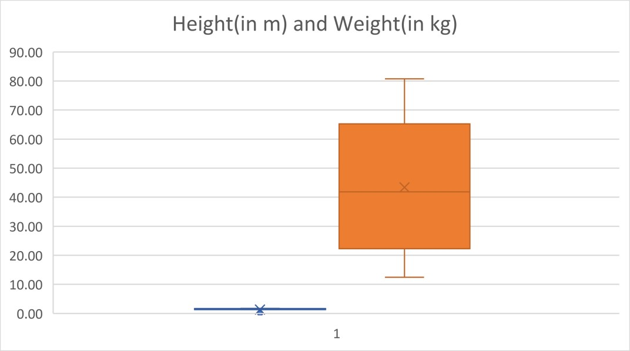
- Plot Box & Whisker graph.

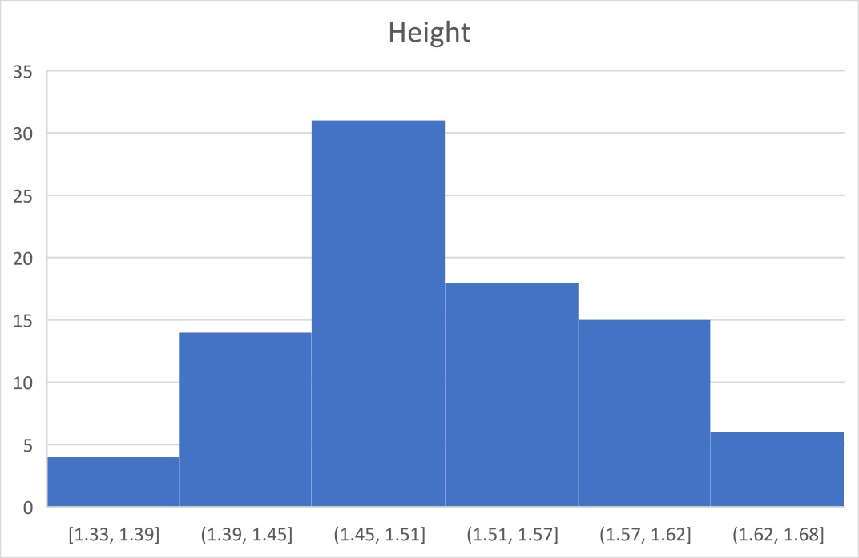
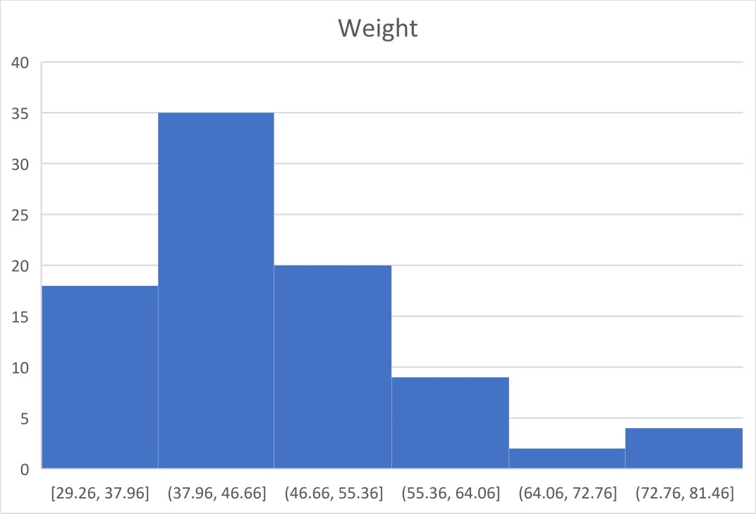
- Comparison of histograms.
4.SUMMARY STATISTICS USING DATA ANALYSIS TOOLPACK

For the data of Height.

Step – 1 : Select ‘Data Analysis’ from ‘Analysis’ section of ‘Data’ tab.

Step – 2 : Select ‘Descriptive Statistics’ and click OK.

Height (M)
Mean | 1.508413636
Standard Error | 0.007813553
Median | 1.4986
Mode | 1.4732
Standard Deviation | 0.073297621
Sample Variance | 0.005372541
Kurtosis | -0.34564739
Skewness | 0.114950996
Range | 0.3302
Minimum | 1.3335
Maximum | 1.6637
Sum | 132.7404
Count | 88
Largest(1) | 1.6637
Smallest(1) | 1.3335
Confidence Level(95.0%) | 0.015530282

Step 3: Raw data as input range ,select the radio button of the select ‘New Worksheet’ and Summary statistics and click OK.

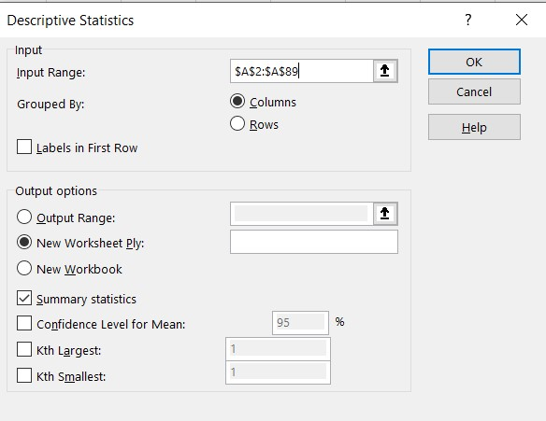

Step – 4 : Generated Result.

Height M
Mean | 1.508413636
Standard Error | 0.007813553
Median | 1.4986
Mode | 1.4732
Standard Deviation | 0.073297621
Sample Variance | 0.005372541
Kurtosis | -0.34564739
Skewness | 0.114950996
Range | 0.3302
Minimum | 1.3335
Maximum | 1.6637
Sum | 132.7404
Count | 88
Largest(1) | 1.6637
Smallest(1) | 1.3335
Confidence Level(95.0%) | 0.015530282

Step – 1 : Select ‘Data Analysis’ from ‘Analysis’ section of ‘Data’ tab.

Step – 2 : Select ‘Descriptive Statistics’ and click OK.
Weight (KG)
Mean | 46.32698969
Standard Error | 1.180230696
Median | 44.96234665
Mode | 47.8539982
Standard Deviation | 11.07154531
Sample Variance | 122.5791156
Kurtosis | 1.145426086
Skewness | 1.0524857
Range | 51.4827374
Minimum | 29.2567098
Maximum | 80.7394472
Sum | 4076.775093
Count | 88
Largest(1) | 80.7394472
Smallest(1) | 29.2567098
Confidence Level(95.0%) | 2.345836305
Step – 3 : Select raw data as ‘Input Range’, select the radio button of the ‘New Worksheet’ and click OK.
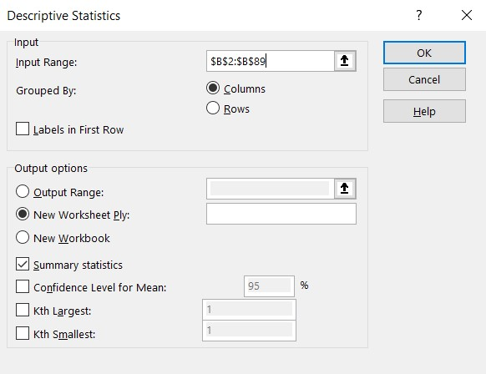
Step – 4 : Generated Result.
5. Summary.
SUMMARY
Here we can find minimum unit and maximum unit by using inbuilt functions such as =min() and =max(), Q1,Q2 and Q3 by using inbuilt functions such as =quartile.inc(range,1); =quartile.inc(range,2); =quartile.inc(range,3), IQR by =Q3-Q1, and LQR and UQR by using =Q1-(IQR*1.5) and =Q3+(IQR*1.5).

The descriptive statistics of the data in shortcut by using data analysis toolpak as mentioned before.
In height, we can see that the minimum height of the class students is
1.33 with the maximum height of the class students is 1.66 where Q1 = 1.4605, Q2 = 1.4986 and Q3 = 1.557338 with the IQR of 0.096838 and LQR of 1.315244 and UQR of 1.702594.

ASSIGNMENT – 8

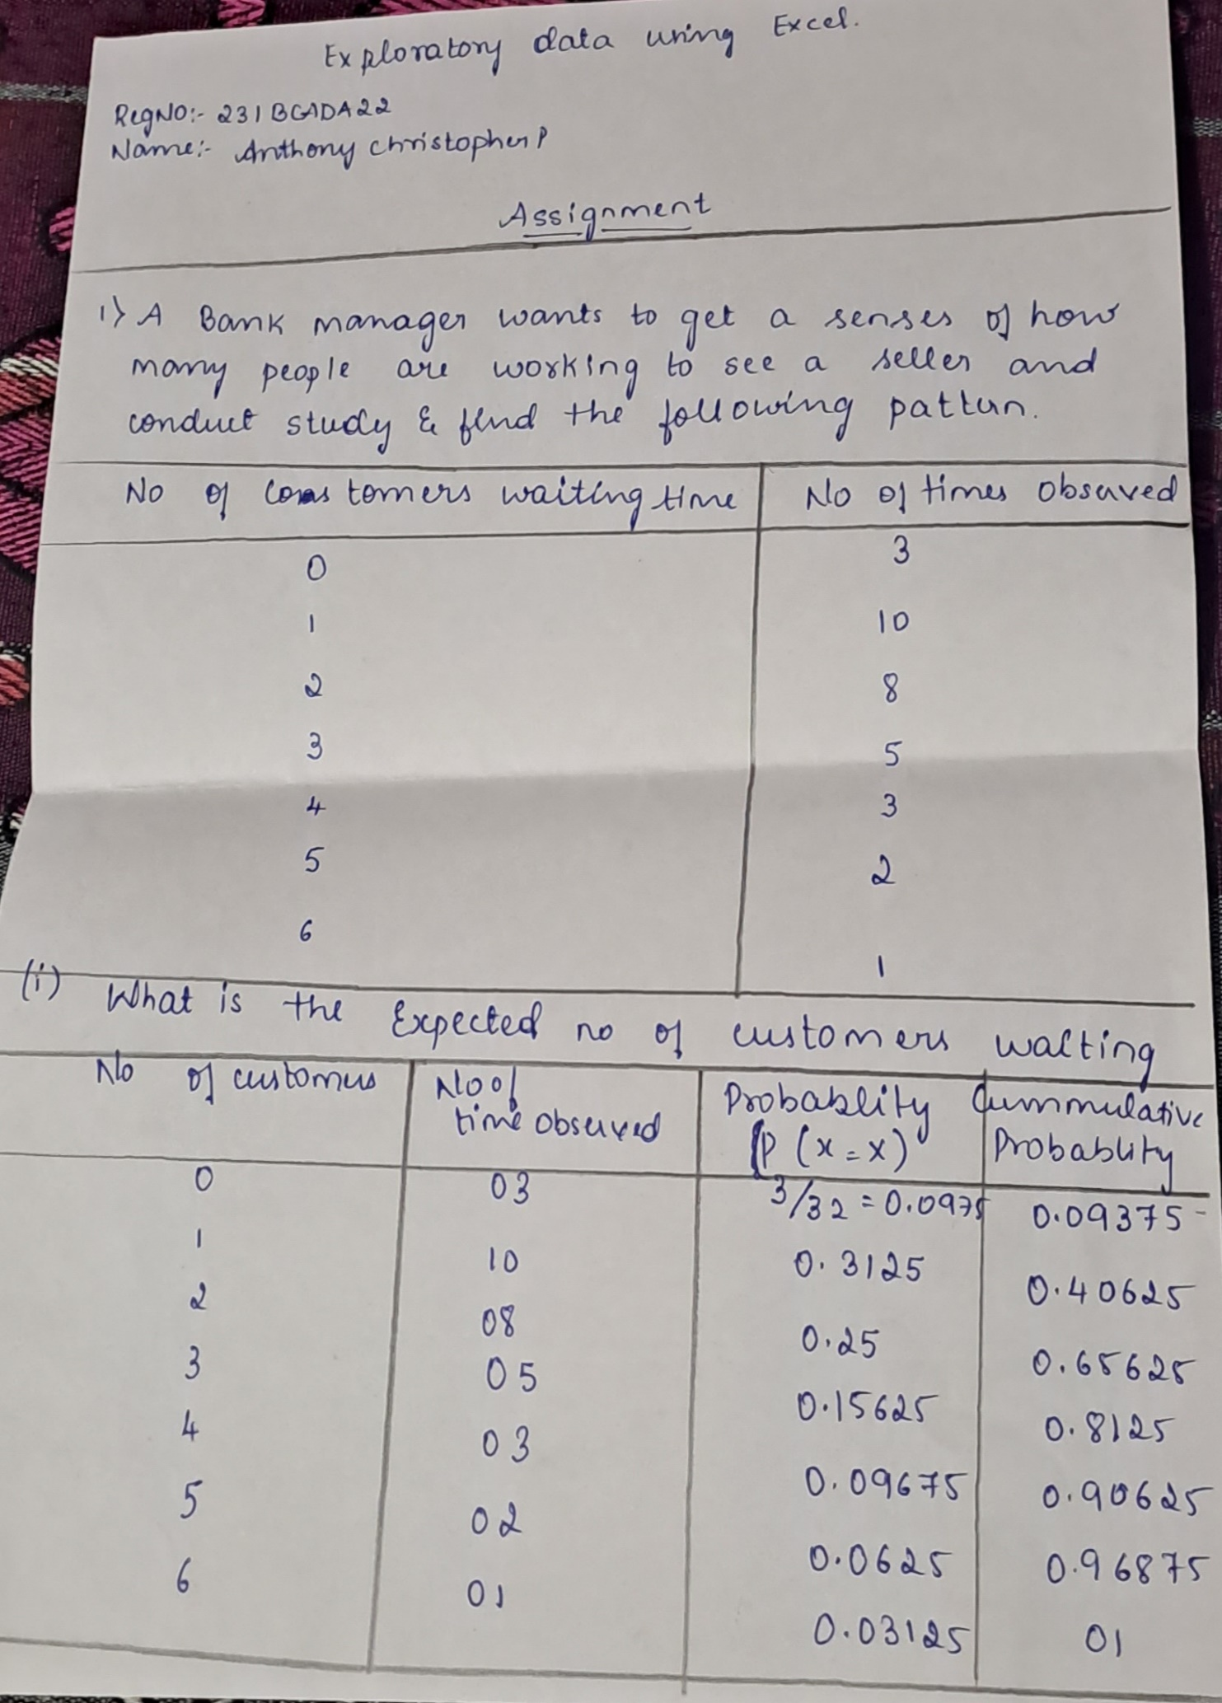


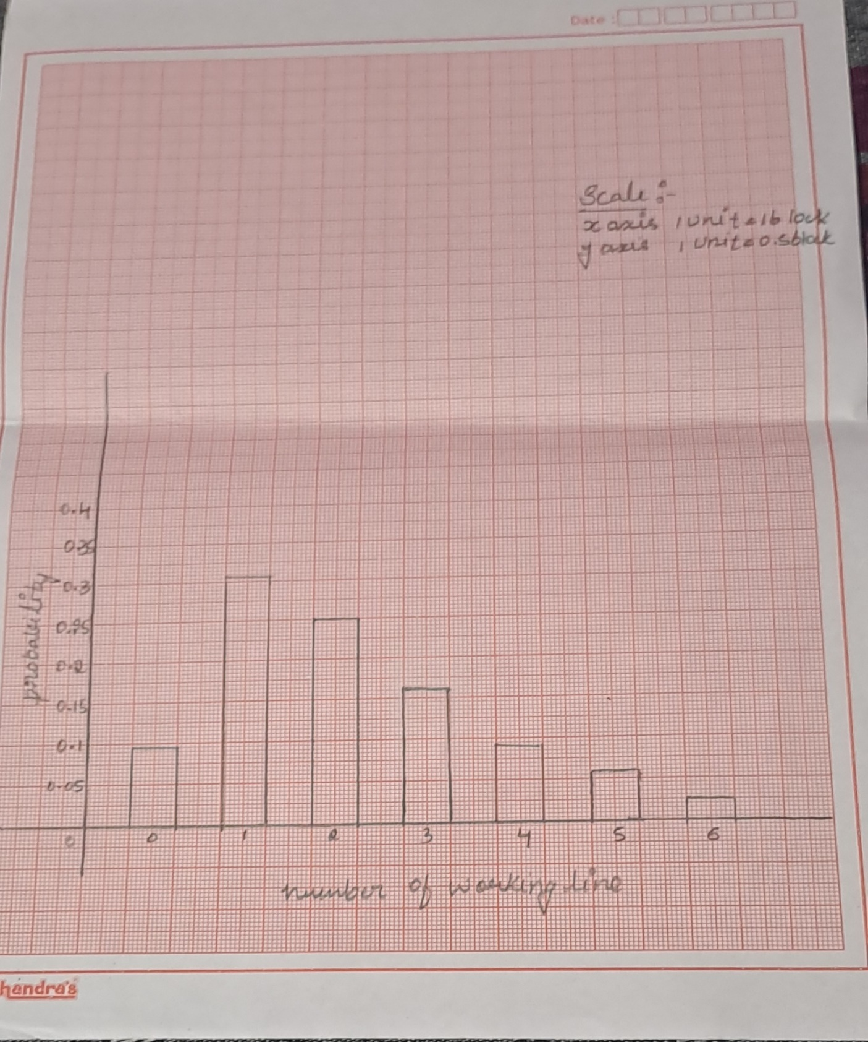

ASSIGNMENT – 9

Daily Demand | Occurrences | Probability | (x-mu)^2
1 | 3 | 0.021428571 | 109.9502041
2 | 10 | 0.071428571 | 89.97877551
3 | 10 | 0.071428571 | 72.00734694
4 | 5 | 0.035714286 | 56.03591837
5 | 2 | 0.014285714 | 42.0644898
6 | 4 | 0.028571429 | 30.09306122
7 | 14 | 0.1 | 20.12163265
8 | 2 | 0.014285714 | 12.15020408
9 | 9 | 0.064285714 | 6.17877551
10 | 5 | 0.035714286 | 2.207346939
11 | 4 | 0.028571429 | 0.235918367
12 | 8 | 0.057142857 | 0.264489796
13 | 2 | 0.014285714 | 2.293061224
14 | 10 | 0.071428571 | 6.321632653
15 | 5 | 0.035714286 | 12.35020408
16 | 3 | 0.021428571 | 20.37877551
17 | 4 | 0.028571429 | 30.40734694
18 | 13 | 0.092857143 | 42.43591837
19 | 15 | 0.107142857 | 56.4644898
20 | 12 | 0.085714286 | 72.49306122
 | 140 | 1
- The manager of a convenience store wants to understand the demand for one of the products she sells, so that she can make a better decision on how many to stock every day. She has the following data gathered over several weeks. Based on this data, what is the value of expected demand and its standard deviation?

Sum | 140
Expected Mean | 11.48571429
Standard Deviation | 6.20539594
Expected Mean + Standard Deviation | 17.69111023
Expected Mean - Standard Deviation | 5.280318345
SUMMARY
We can find expected mean by using function =sumproduct(daily demand, probability) and standard deviation by function =sqrt(sumproduct(probability, (x-mu)^2)).

ASSIGNMENT – 10

Height M | Weight kg
1.60 | 49.44
1.65 | 62.60
1.65 | 75.75
1.53 | 48.99
1.45 | 43.09
1.61 | 52.62
1.56 | 47.97
1.50 | 45.59
1.52 | 47.85
1.48 | 44.45
1.47 | 46.04
1.55 | 53.07
1.52 | 65.88
1.54 | 46.04
1.46 | 43.54
1.52 | 62.37
1.46 | 45.81
1.58 | 74.39
1.52 | 55.57
1.50 | 46.15
1.49 | 47.85
1.48 | 42.18
1.59 | 45.81
1.56 | 44.68
1.58 | 42.64
1.57 | 43.54
1.50 | 37.31
1.52 | 39.35
1.44 | 39.01
1.49 | 40.60
Here we’re going to apply Karl Pearson’s correlation method on few data sets such as following:-
The data below is a 2 variable distribution and numeric in nature.

Actually due to vast distribution we took sample data of height and weight of 30 students out of the population data of 88 students.
To perform correlation on the whole distribution, there are certain steps to be followed using data analysis tool pack using following steps
.

Step – 1 : Go to ‘Data tab’ and select ‘Data analysis’ from ‘Analysis’ section.
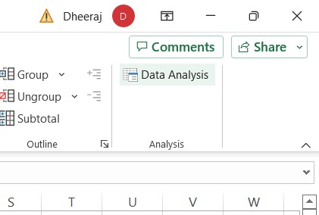

Step – 2 : Select ‘correlation’ and click OK.
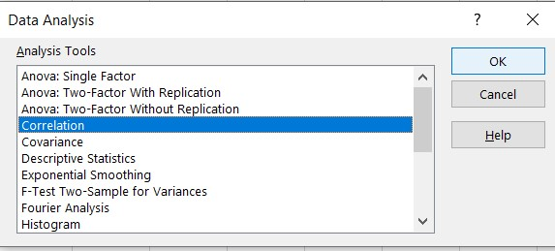

Step – 3 : Select raw data in ‘input range’ section, select ‘labels in the first row’ and select ‘New Worksheet Ply’ and click OK.
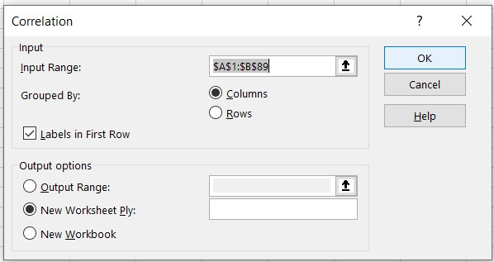

Step – 4 : Generated result.
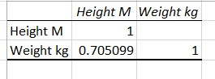

age | sex | cp | trestbps | chol | fbs | restecg | thalach | exang | oldpeak | slope | ca | thal | target
52 | 1 | 0 | 125 | 212 | 0 | 1 | 168 | 0 | 1 | 2 | 2 | 3 | 0
53 | 1 | 0 | 140 | 203 | 1 | 0 | 155 | 1 | 3.1 | 0 | 0 | 3 | 0
70 | 1 | 0 | 145 | 174 | 0 | 1 | 125 | 1 | 2.6 | 0 | 0 | 3 | 0
61 | 1 | 0 | 148 | 203 | 0 | 1 | 161 | 0 | 0 | 2 | 1 | 3 | 0
62 | 0 | 0 | 138 | 294 | 1 | 1 | 106 | 0 | 1.9 | 1 | 3 | 2 | 0
58 | 0 | 0 | 100 | 248 | 0 | 0 | 122 | 0 | 1 | 1 | 0 | 2 | 1
58 | 1 | 0 | 114 | 318 | 0 | 2 | 140 | 0 | 4.4 | 0 | 3 | 1 | 0
55 | 1 | 0 | 160 | 289 | 0 | 0 | 145 | 1 | 0.8 | 1 | 1 | 3 | 0
46 | 1 | 0 | 120 | 249 | 0 | 0 | 144 | 0 | 0.8 | 2 | 0 | 3 | 0
54 | 1 | 0 | 122 | 286 | 0 | 0 | 116 | 1 | 3.2 | 1 | 2 | 2 | 0
71 | 0 | 0 | 112 | 149 | 0 | 1 | 125 | 0 | 1.6 | 1 | 0 | 2 | 1
43 | 0 | 0 | 132 | 341 | 1 | 0 | 136 | 1 | 3 | 1 | 0 | 3 | 0
34 | 0 | 1 | 118 | 210 | 0 | 1 | 192 | 0 | 0.7 | 2 | 0 | 2 | 1
51 | 1 | 0 | 140 | 298 | 0 | 1 | 122 | 1 | 4.2 | 1 | 3 | 3 | 0
52 | 1 | 0 | 128 | 204 | 1 | 1 | 156 | 1 | 1 | 1 | 0 | 0 | 0
34 | 0 | 1 | 118 | 210 | 0 | 1 | 192 | 0 | 0.7 | 2 | 0 | 2 | 1
51 | 0 | 2 | 140 | 308 | 0 | 0 | 142 | 0 | 1.5 | 2 | 1 | 2 | 1
54 | 1 | 0 | 124 | 266 | 0 | 0 | 109 | 1 | 2.2 | 1 | 1 | 3 | 0
50 | 0 | 1 | 120 | 244 | 0 | 1 | 162 | 0 | 1.1 | 2 | 0 | 2 | 1
58 | 1 | 2 | 140 | 211 | 1 | 0 | 165 | 0 | 0 | 2 | 0 | 2 | 1

Step – 1 : Go to ‘Data tab’ and select ‘Data analysis’ from ‘Analysis’ section.

Step – 2 : Select ‘correlation’ and click OK.

Step – 3 : Select raw data in ‘input range’ section, select ‘labels in the first row’ and select ‘New Worksheet Ply’ and click OK.
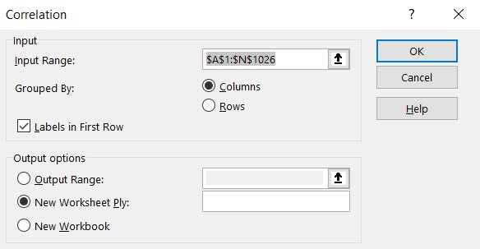
Step – 4 : Generated result.
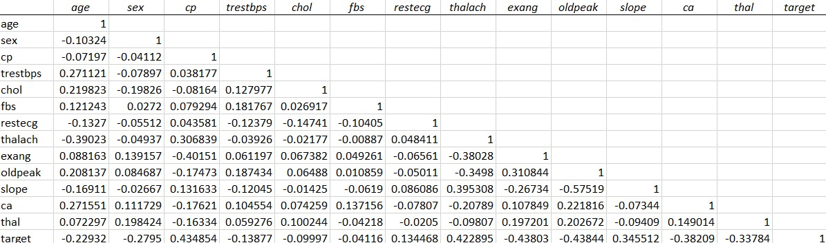

SUMMARY
By applying the Karl Pearson’s correlation method inbuilt in Excel we are able to see how the data is correlated to each other with the data analysis tool pack with the step-by-step procedure demonstrated above.
And in the data of the heart patients under target where 0 represents to no and 1 represents to yes which means what patient is a heart patient and who is not. With the correlation represented in the above image we can see how a variable is related to one another and provide proper values.

Here we’re going to apply Karl Pearson’s correlation method on few data sets such as following:-
The data below is a 2 variable distribution and numeric in nature.

Actually due to vast distribution we took sample data of height and weight of 30 students out of the population data of 88 students.
To perform correlation on the whole distribution, there are certain steps to be followed using data analysis tool pack using following steps

ASSIGNMENT – 7

47.04398 | 46.61656 | 23.95147 | 26.25522 | 9.742556
4.770054 | 41.72804 | 40.08385 | 37.08479 | 24.074
19.74278 | 25.90737 | 3.957669 | 33.88783 | 21.32983
28.12262 | 11.4302 | 39.81056 | 32.89275 | 46.89584
27.82627 | 46.97626 | 33.12953 | 30.02536 | 30.55776

Using Functions.
=RAND(), =RANDBETWEEN(MIN,MAX), =RANDARRAY([ROWS],[COLUMN],[MIN],[MAX],[INTEGER]).
Using =RAND() we can get any random number generated by Excel such as if I apply this function I got a random number of 0.667278.
Using =RANDBETWEEN(MIN,MAX) we can get random number generated by Excel between minimum value and maximum value. Such as, if I apply this function with minimum value of 1 and maximum value of 50 I get a value of 18.
Using =RANDARRAY([ROWS],[COLUMN],[MIN],[MAX],[INTEGER]) we can get random number generated by Excel by initialising rows, column, minimum value, maximum value and integer value. Such as, if I apply this function with rows as 5, column as 5, minimum value as 1 and maximum value as 50 then I get the following table.

Using Data Analysis Toolpack.

By Normal distribution.
Step – 1 : Go to ‘Data tab’ and select ‘Data analysis’ from ‘Analysis’ section.
Step – 2 : Select ‘Random Number Generation’ option and click OK.
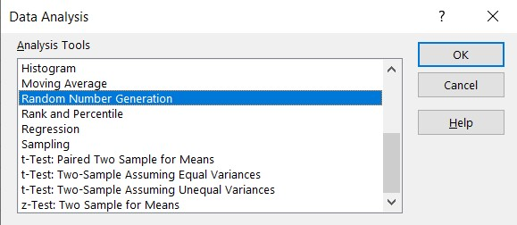
302.3161 | -93.3744 | 60.41325 | -83.3259 | 180.4305
41.35307 | -59.5867 | -49.8714 | -110.927 | 172.2038
-57.2903 | 43.52023 | 24.25826 | -101.368 | -149.818
-126.872 | 152.2575 | -114.478 | -205.225 | -228.003
-7.79132 | 144.9189 | -105.523 | 197.4322 | -89.6515

Step – 3 : Enter values as m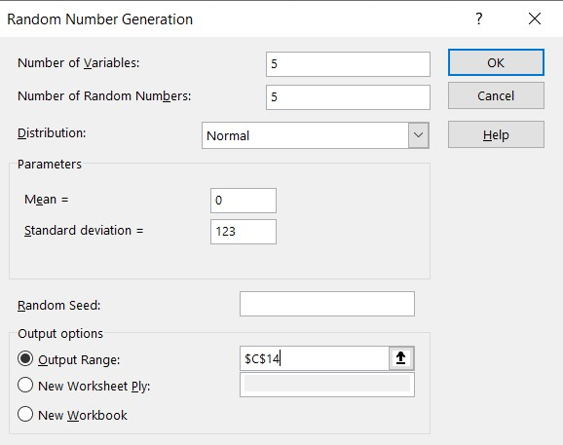entioned in picture below.

Step – 4 : Generated Result.

For Binomial Distribution.
Step – 1 : Go to ‘Data tab’ and select ‘Data analysis’ from ‘Analysis’ section.

Step – 2 : Select ‘Random Number Generation’ option and click OK.

3 | 3 | 0 | 1 | 3
1 | 1 | 1 | 0 | 1
1 | 2 | 1 | 1 | 2
2 | 2 | 2 | 1 | 1
0 | 2 | 0 | 1 | 0

Step – 3 : Enter values as mentioned in picture below.



